**MSCD664**

**Lab 5 – Download and Install Neo4j for your computer platform**

**Name: Rohan Purohit**

**Date: Oct 2 2016**

-----------------------------------------------------------------------------------

The purpose of this lab is to become familiar with the Neo4j Environment and the Cypher Graph Query language. You will perform the following tasks in the lab:

* Starting your Neo4j database
* Exploring the Neo4j console and environments
* Perform the tutorials and the sample Movie application
* Implement a custom Graph and perform queries against the database

*Read Chapter 11 in the NoSQL Distilled text and chapter 7 in the Seven Weeks text. Also, ensure you have reviewed the Getting Started with Cypher (*[*http://neo4j.com/developer/cypher-query-language/*](http://neo4j.com/developer/cypher-query-language/)*) and the From SQL to Cypher – A Hands on Guide (*[*http://neo4j.com/developer/guide-sql-to-cypher/*](http://neo4j.com/developer/guide-sql-to-cypher/)*) web pages. These are critical for understanding what you are doing in this lab.*

To get an “A” grade on this lab:

* Answer all questions.
* Provide output of steps that require you to perform a task. The output can be a cut and paste from the screen to a word document or screen shots. I need to see something to verify that you ran the labs. I’m expecting you to turn in a word document that contains each question and also the corresponding answers to questions asked and output from Cypher statements.
* Tasks that require an output will be indicated clearly.
* Text you should enter will look like this:

Enter this text

<return> means to hit the return or enter key on your keyboard.

As mentioned in the “From the Expert Video” on Neo4j by Lyle Steinhardt, you must download and install the community edition of Neo4j from the website: [**http://neo4j.com/download/**](http://neo4j.com/download/)

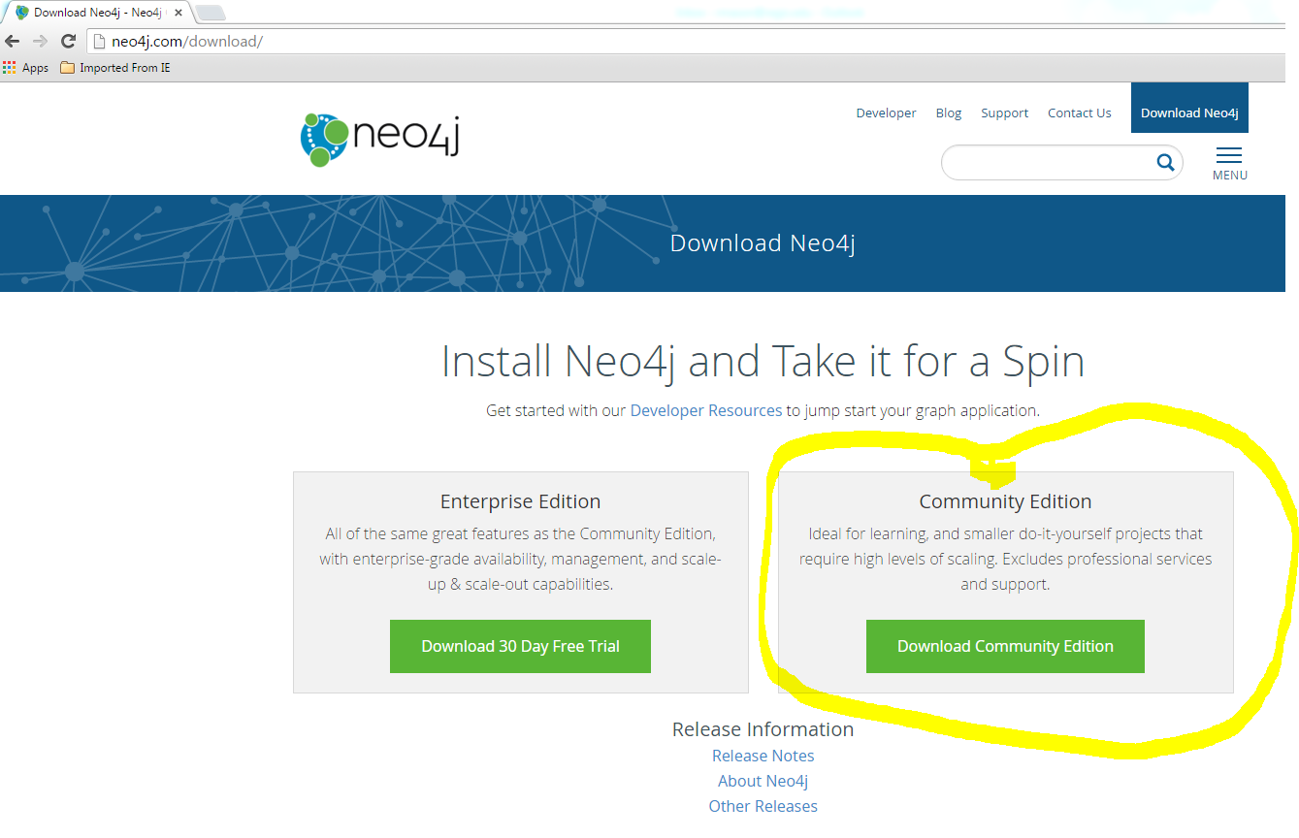

**-----------------------------------------------------------------------------------**

**Part 1: Understanding Your Neo4j Environment**

**-----------------------------------------------------------------------------------**

Mac OSX (*nix OS)

1. Start a terminal session
2. Navigate to your Ne04j bin directory
3. Start the Neo4j console by entering:

./neo4j console <return>

1. When the remote interface ready line appears, open a browser (IE, Firfeox, Chrome, etc.) and enter in the address bar:

<http://localhost:7474> <return>

Windows OS

1. Go to Start button and click Neo4j Community application
2. Click Start button on Neo4j Application console
3. Click on link in console window.

Provide a screenshot of your browser below:

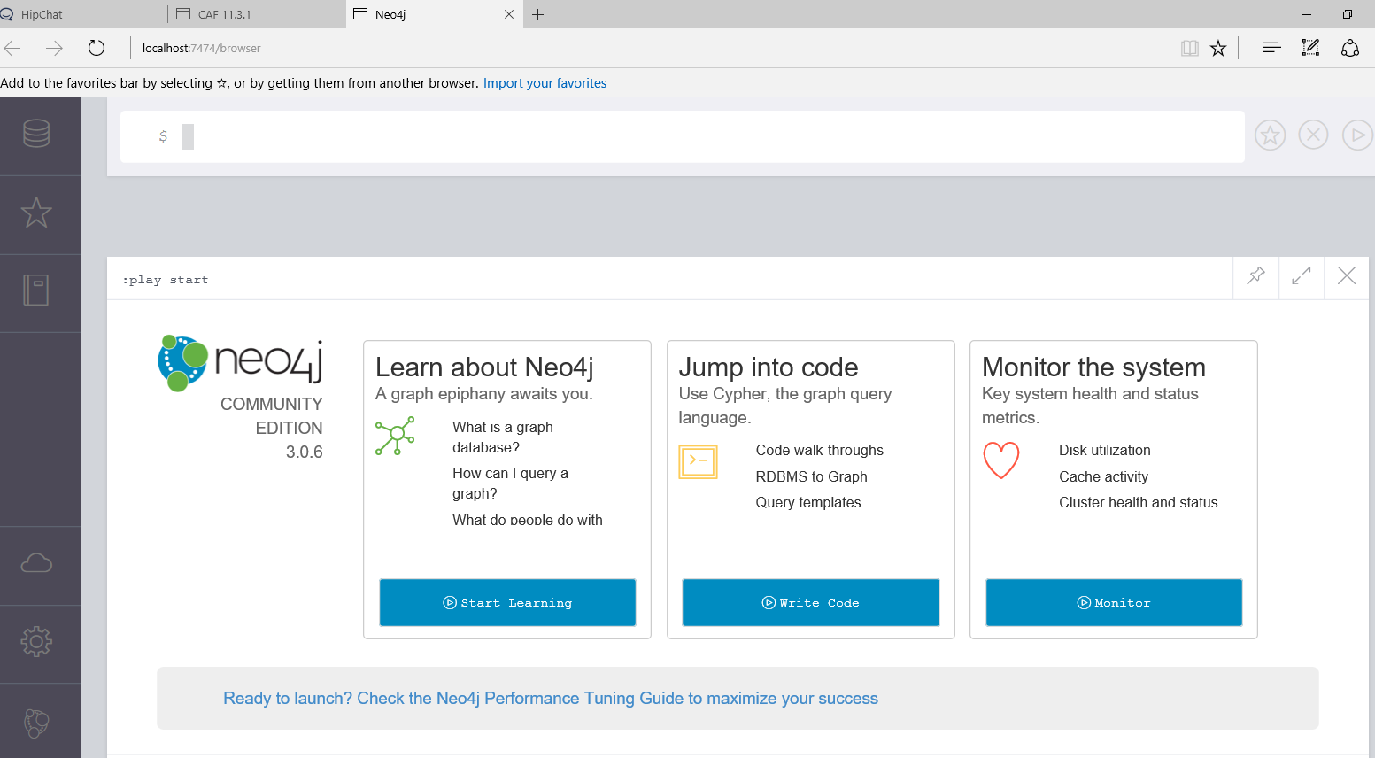

2. In the center of your Neo4j Environment you can see:

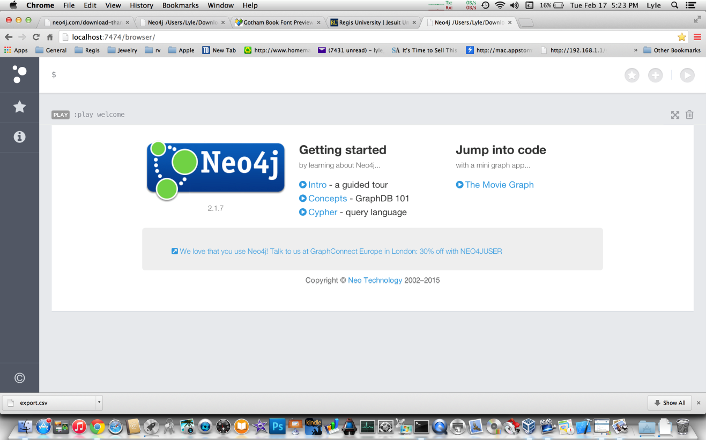

Click the Intro- a guided tour link and review the different parts of this environment.

Provide a screen shot of the last page of the tour below:

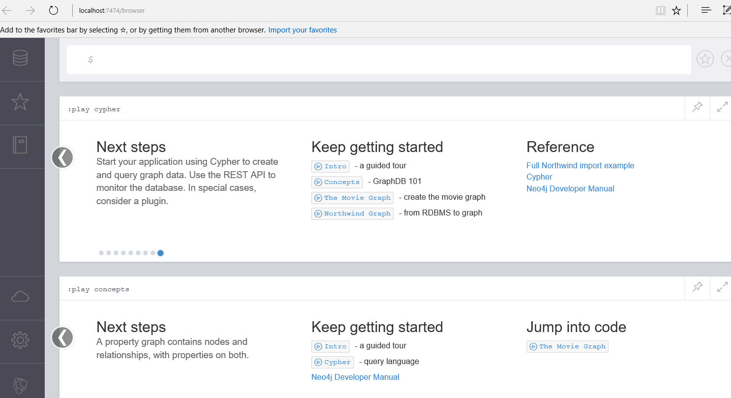

**-----------------------------------------------------------------------------------**

3. Now we will explore a bit more of the environment. Click the three circles at the top of the sidebar. Your browser should change to look like the following:

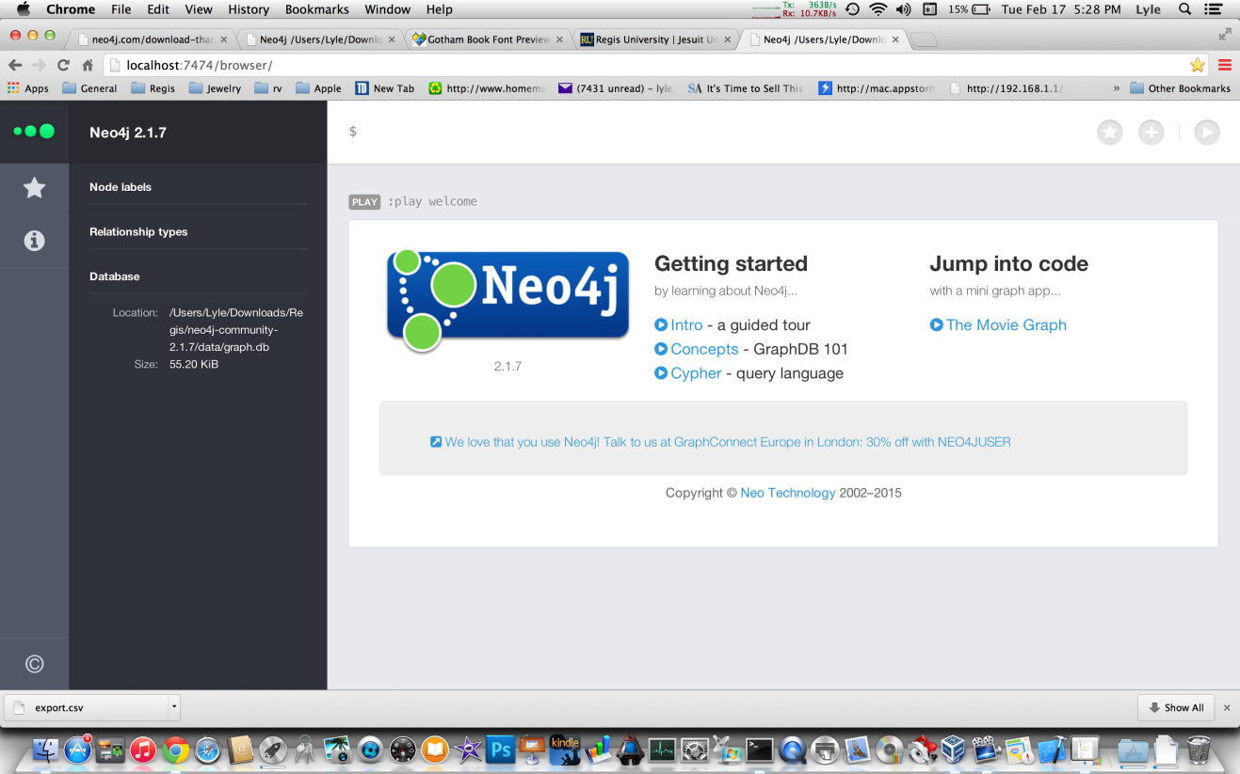

Note that there is some information along the right side of the sidebar. If this is the first time you are using this instance of Neo4j, and you haven’t added any nodes yet, there should be nothing under the first two sections labeled: Node labels and Relationship types. The last section provides some information about your Database location and size.

What is your database location and what is its size?

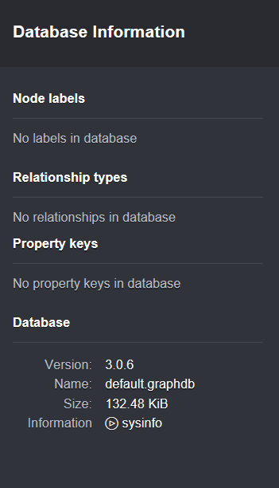

**-----------------------------------------------------------------------------------**

4. Click the Star icon in the sidebar. Your screen should now look like this:

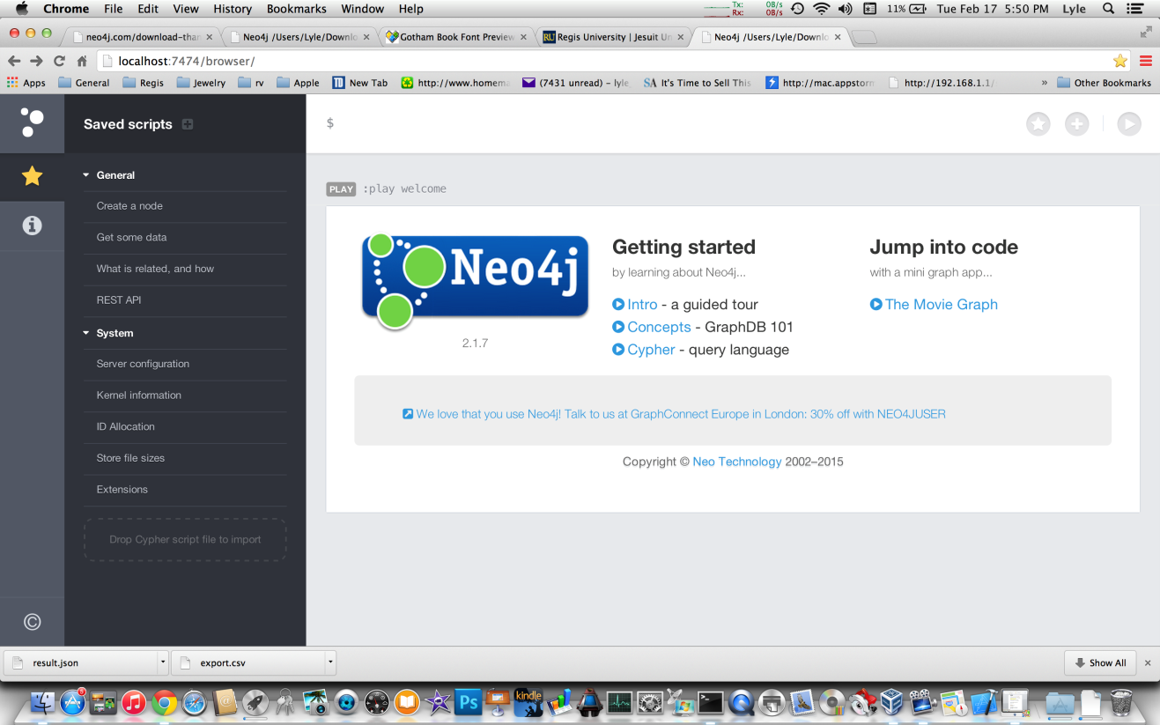

If you run your mouse cursor over each of the entries in the sidebar, the text highlights and a green arrow appears. Clicking on the highlighted text will load the code into the Editor for you to review. You can then execute the code by hitting the play button in the Editor. If you hit the green play button in the sidebar, the code is executed without being displayed. Click the Server configuration text and then click the Editor play button.

Provide a screenshot of the output below:

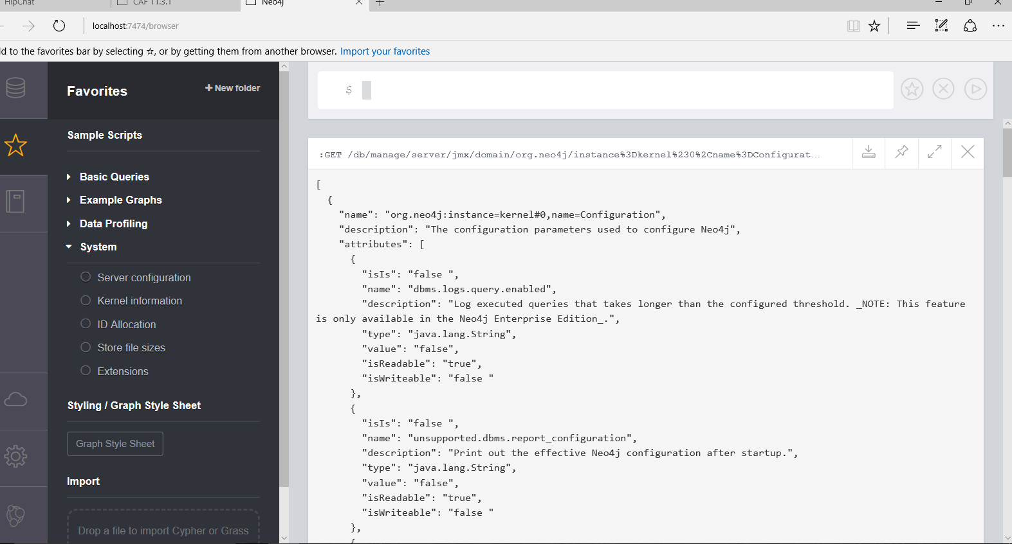

-----------------------------------------------------------------------------------

5. Now click the circle icon with the letter I in the center on the sidebar. You should now see something like this:

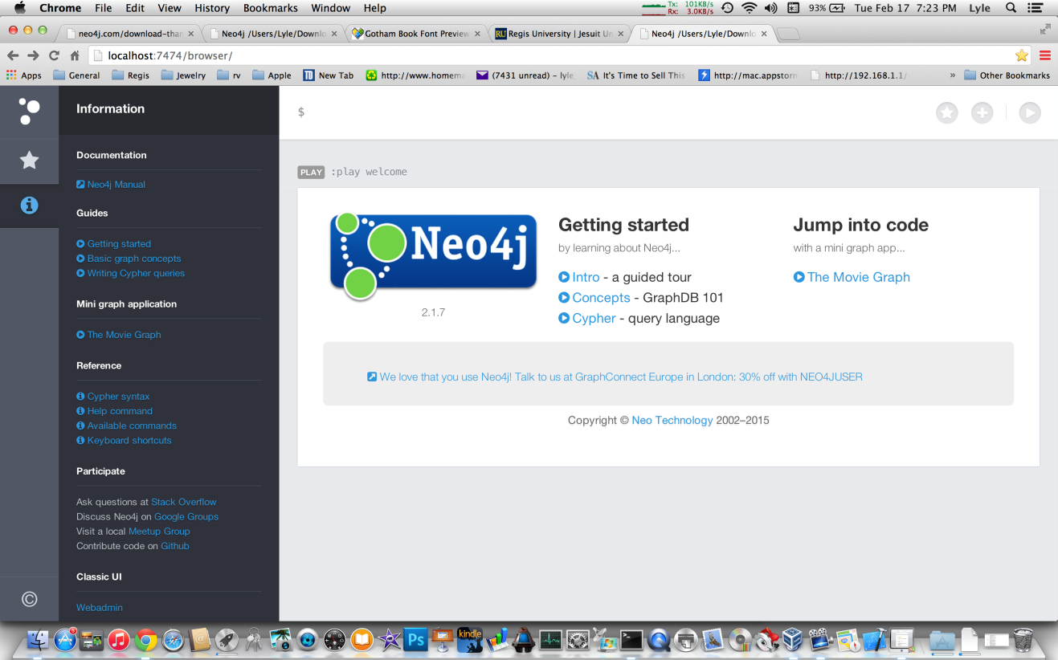

Notice all the blue colored text. These links will provide you a wealth of information about Neo4j and Cypher. The first section, Documentation, contains a link to the Neo4j Reference Manual. We’ll get to that in a bit.

Notice the next two sections, Guides and Mini graph application. The links here are the same as the links in the Window to the right.

The Reference section provides some additional information about Cypher and how to use some of the commands. Feel free to explore these links.

Go down to the bottom of the sidebar and click the Webadmin link.

Paste a screenshot of the resulting screen below:

Webadmin has been deprecated.

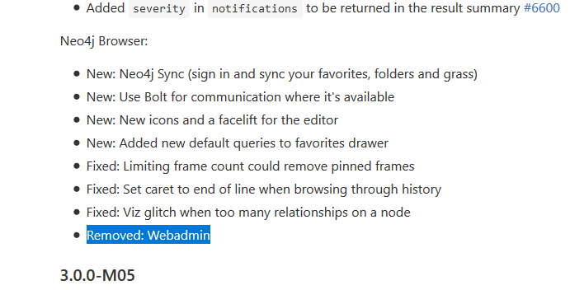

-----------------------------------------------------------------------------------

6. This is the Webadmin console for Neo4j. Take some time and explore this interface and see the information you can get from the different tabs here. If you’ve created any

Nodes, Properties or Relationships, you will see the graph display a chart of your database.

Now return to the Neo4J Web interface: <http://localhost:7474>

Close the sidebar by clicking the three horizontal circles twice.

**PART II – Getting Familiar with Cypher**

**-----------------------------------------------------------------------------------**

7. Find the Movie Graph application. You may have to look around to find this application.

-----------------------------------------------------------------------------------

8. Click the Movie Graph link to start the application. We will run through the guide and you will execute the various Cypher statements to produce some results. Now click the > button on the Movie Graph Guide. Your screen should now look like this:

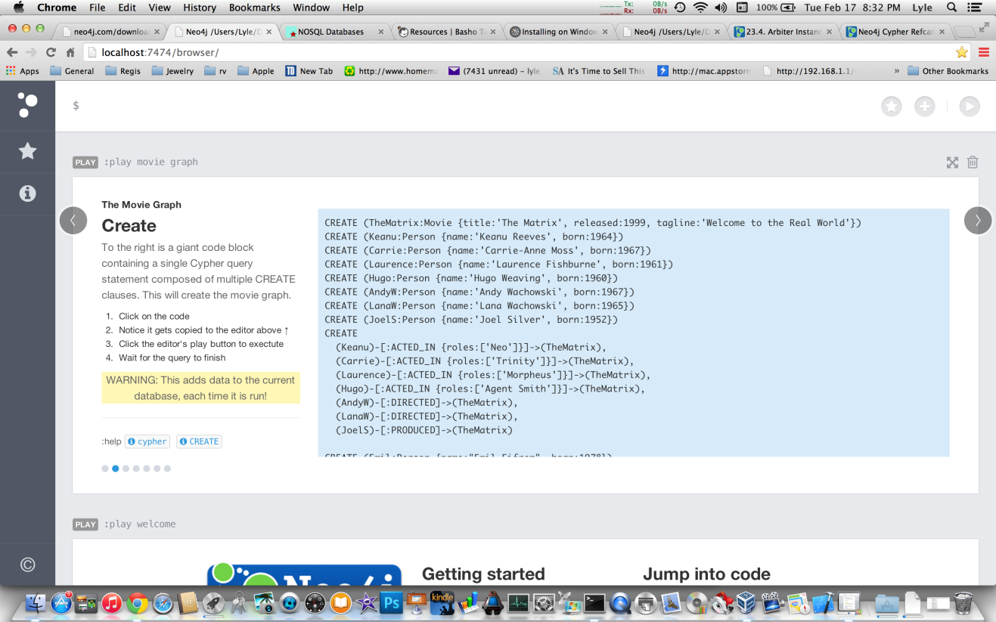

Click the code in the blue box to enter it into the Editor. Then click the Editor Play button to execute the code.

Paste a copy of the resulting screen below:

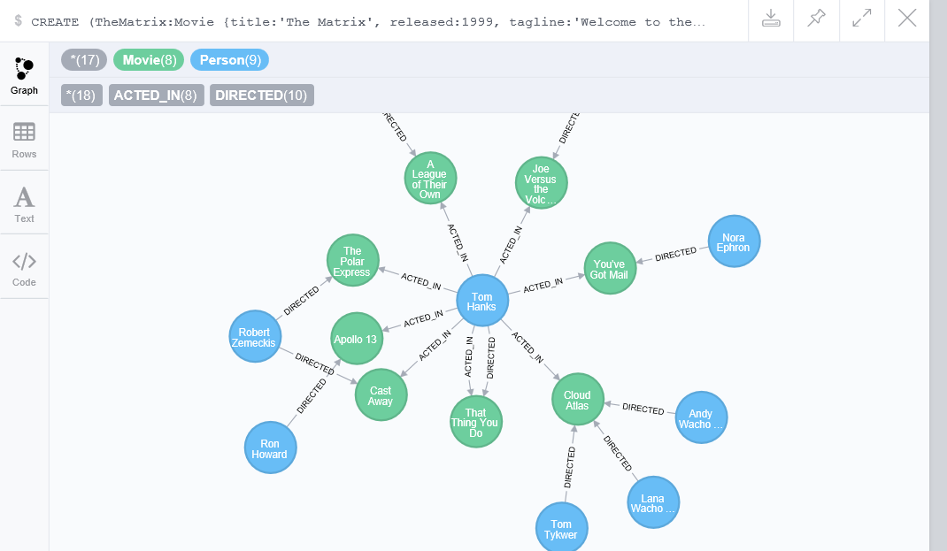

-----------------------------------------------------------------------------------

9. Scroll down to the Movie Graph Guide and click the > to go to the next slide. This should be the Find slide. Click on the Find Tom Hanks node Cypher query and execute it. It should produce results like this:

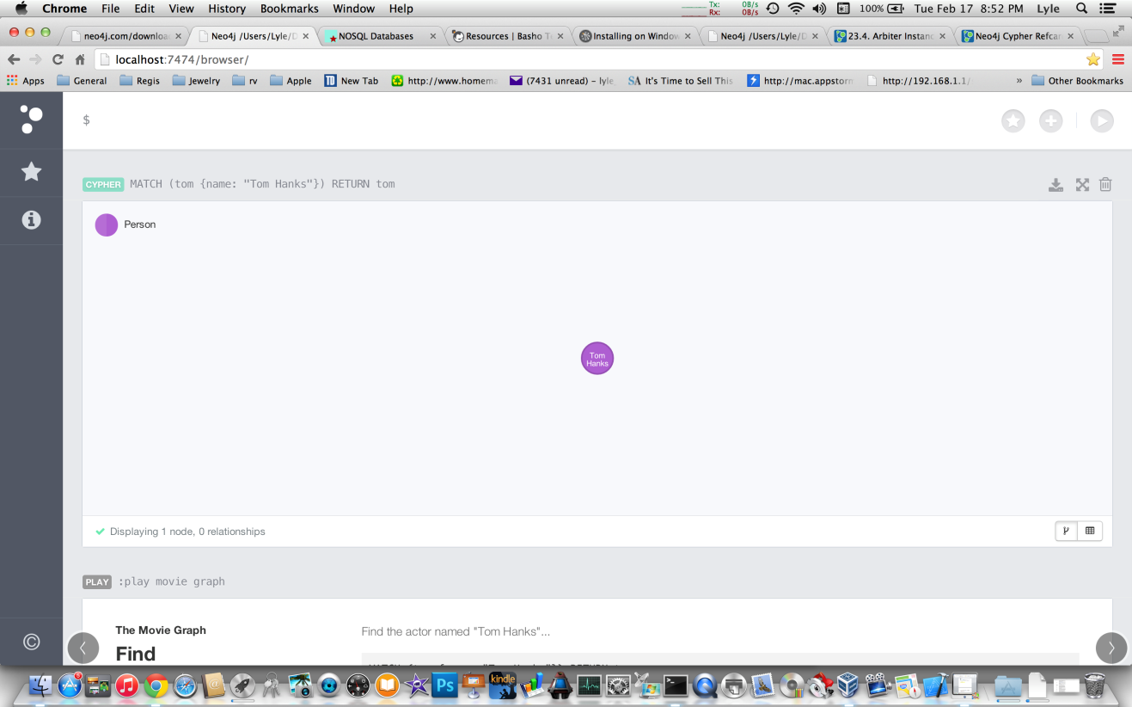

If you see a circle with a number in it, then single click the circle and a black window will appear. This is the properties inspector and style guide. Click the Eye tab and you will see a Caption dropdown arrow. Click the arrow and change the caption to Name. You will now see Tom Hanks in the purple circle instead of the Node ID. You can experiment with all the various options present here.

Now click on the table like button in the lower right hand corner of the results window.

Paste a screenshot of the result below:

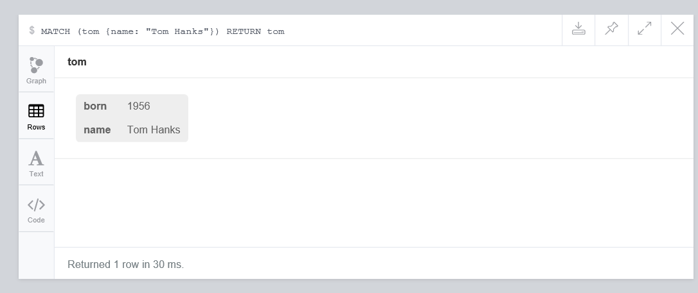

What information is being displayed here?

Properties for Tom Hanks Node which give details about when he was born and his name.

Click the graph button to the left of the tab and you should see your node again. Now double click the node and what happens?

Paste copy of the results below:

We get all the movie entities that the person entity is linked to via the acted in relationship.

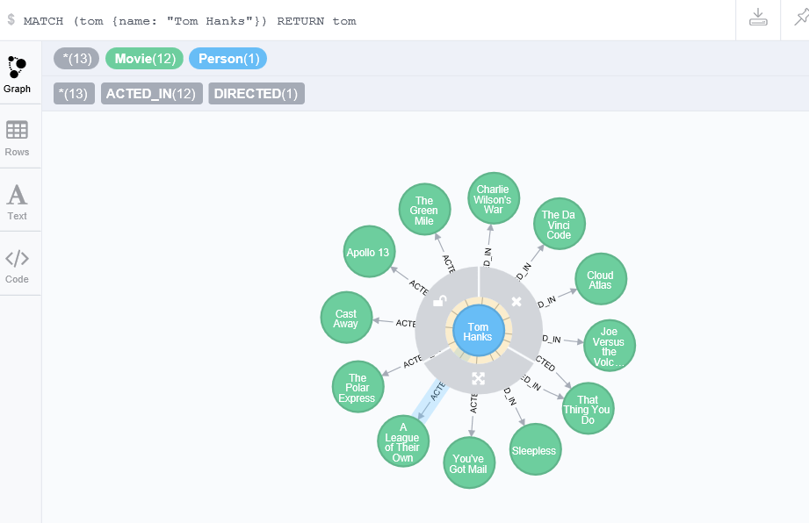

-----------------------------------------------------------------------------------

10. Now scroll back down to the Find panel and click the code for displaying a list of people. Limit your list to 25 and include the year they were born in the output. Execute your code.

Place a screenshot of your results below:

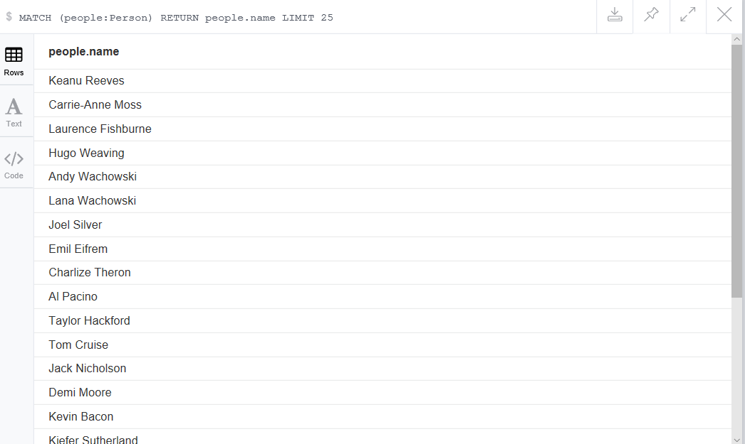

What is the difference between the last two queries you executed?

In the last query I searched for all person nodes and returned their names (up to first 25 people in the result set). In the first query I searched person with the name property of Tom Hanks.

-----------------------------------------------------------------------------------

11. Now looking at the code for displaying Tom Hanks and the code for listing just people names, enter a cypher query to return 5 people nodes only.

Ensure the Graph button is clicked on the results screen and past a copy below:

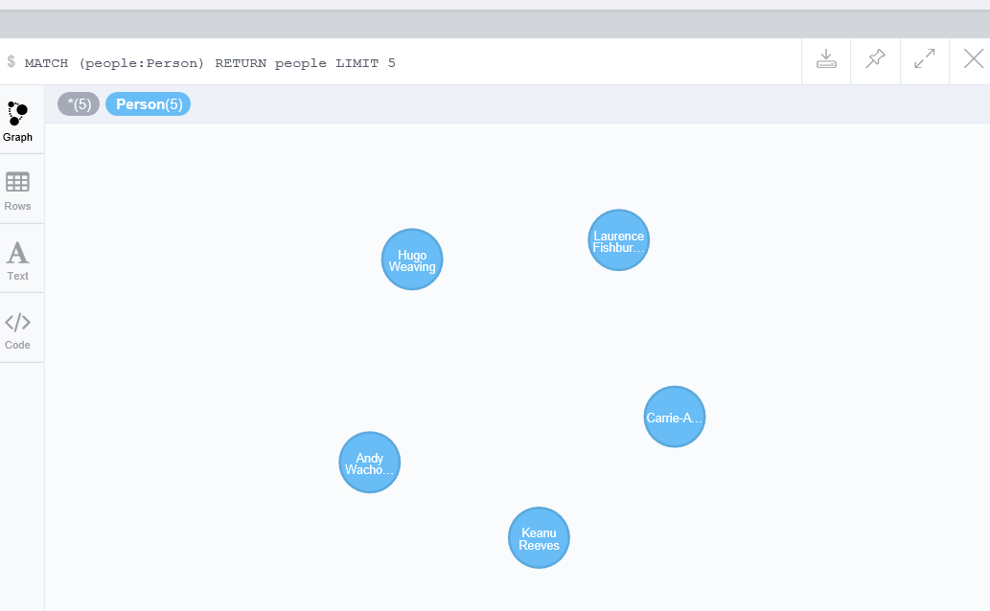

Now click the table button and paste a screenshot below:

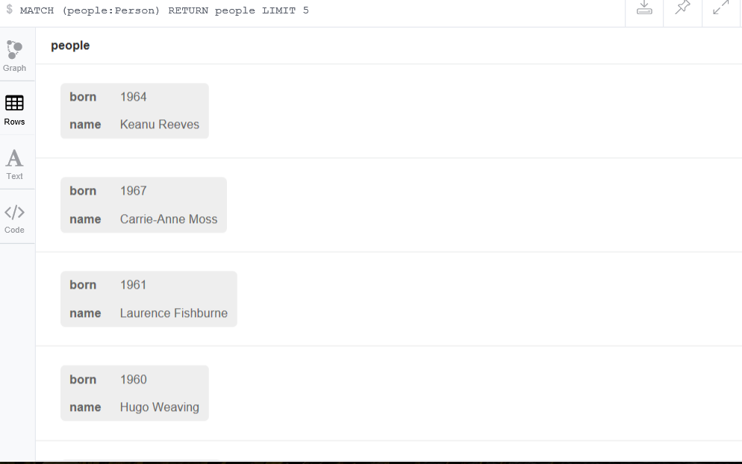

Why are there no arrows connecting the nodes together?

Because we did not specify any relationships to capture between the nodes.

-----------------------------------------------------------------------------------

12. A. Return to the Find panel in the Movie Graph application and click the > button.

B. You now should be on the Query panel. Click the query to find all the co-actors of Tom Hanks.

C. Execute the query and make sure the table button is toggled.

D. Note that Meg Ryan’s name appears in the list multiple times. Modify the query to remove duplicates from the list.

Paste a screenshot of your results below: I used the DISTINCT keyword

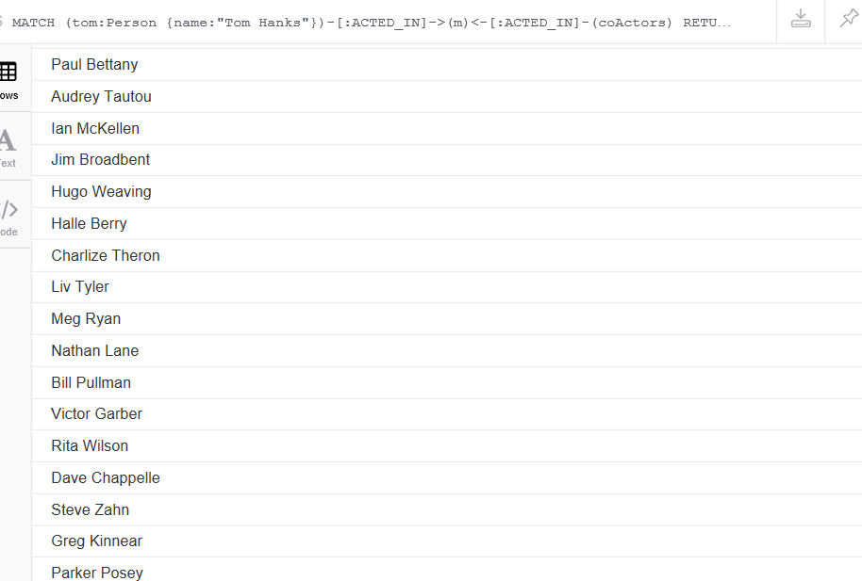

-----------------------------------------------------------------------------------

13. Back to the Movie Graph panel again, and click the > button. You should now be on the Solve panel. Click the code for movies and actors up to four hops away from Kevin Bacon. Execute the code.

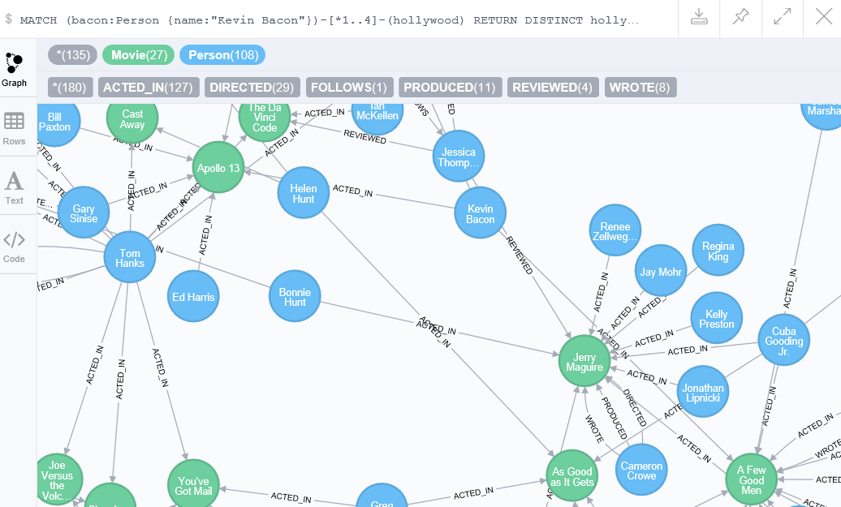

How many nodes were returned?

135 nodes total were returned.

27 Movie Nodes and 108 Person Nodes.

Now find out which actor returns fewer nodes: Ed Harris or Helen Hunt.

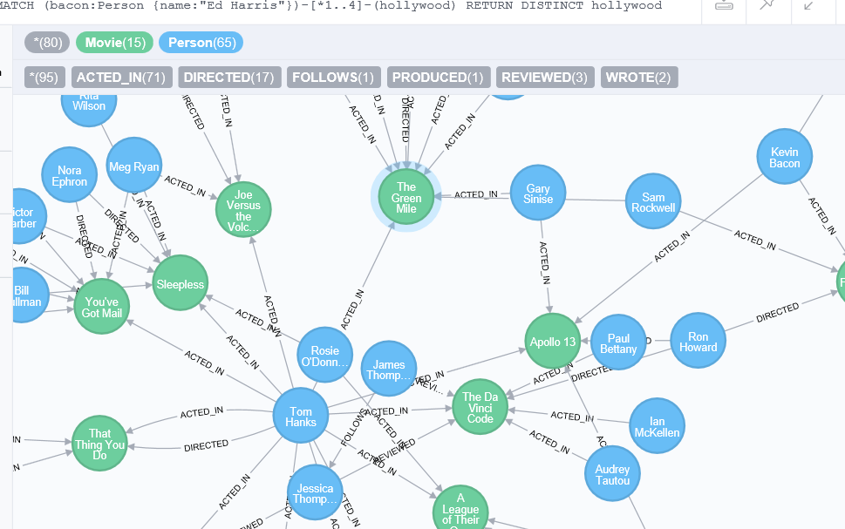

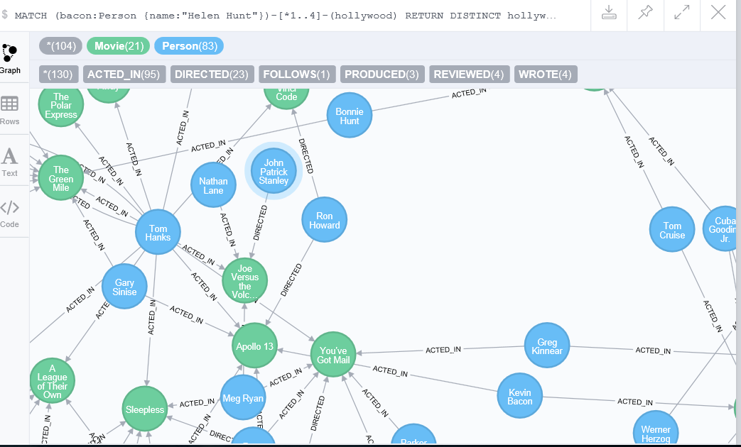

How many nodes?

Ed Harris returns fewer nodes. Around 80 total nodes.

-----------------------------------------------------------------------------------

14. Return to the Solve panel and click the > button. You should now be on the Cleanup panel. Go ahead and delete the all Movie and Person nodes and relationships.

Past a screenshot demonstrating that all nodes are deleted from the database below:

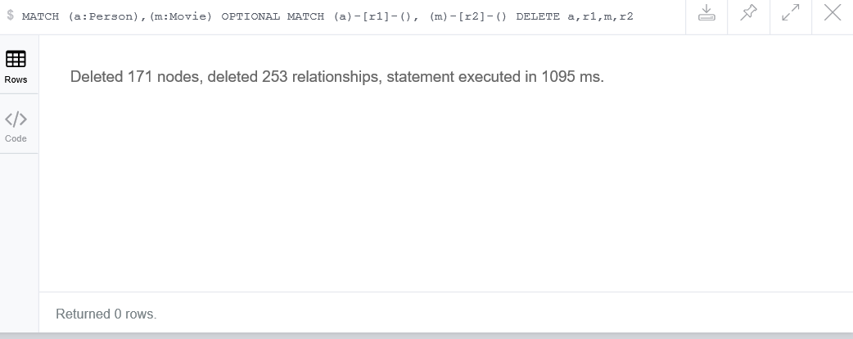

-----------------------------------------------------------------------------------

15. Now click the three circles on the left sidebar.

Paste a screenshot of your browser below:

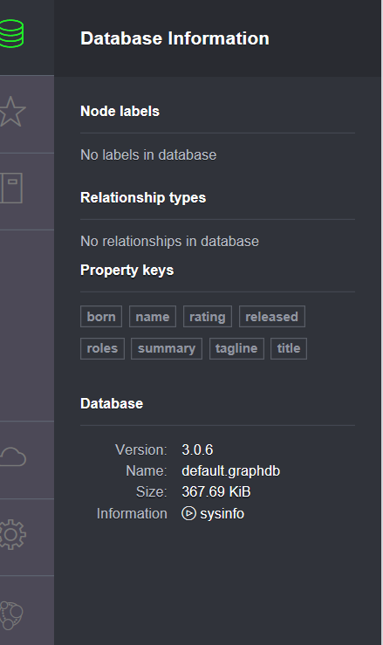

Notice that there are still Node Labels, Relationship types and Property types defined in the database. Node Labels, Relationship types and property types are not deleted because they are defined as concepts in the database. The only way to remove them would be to delete the actual database folder on your system. Feel free to attempt this on your own. You can always just reinstall the Neo4J if something goes wrong.

-----------------------------------------------------------------------------------

**Part II – Demonstrating your Learning**

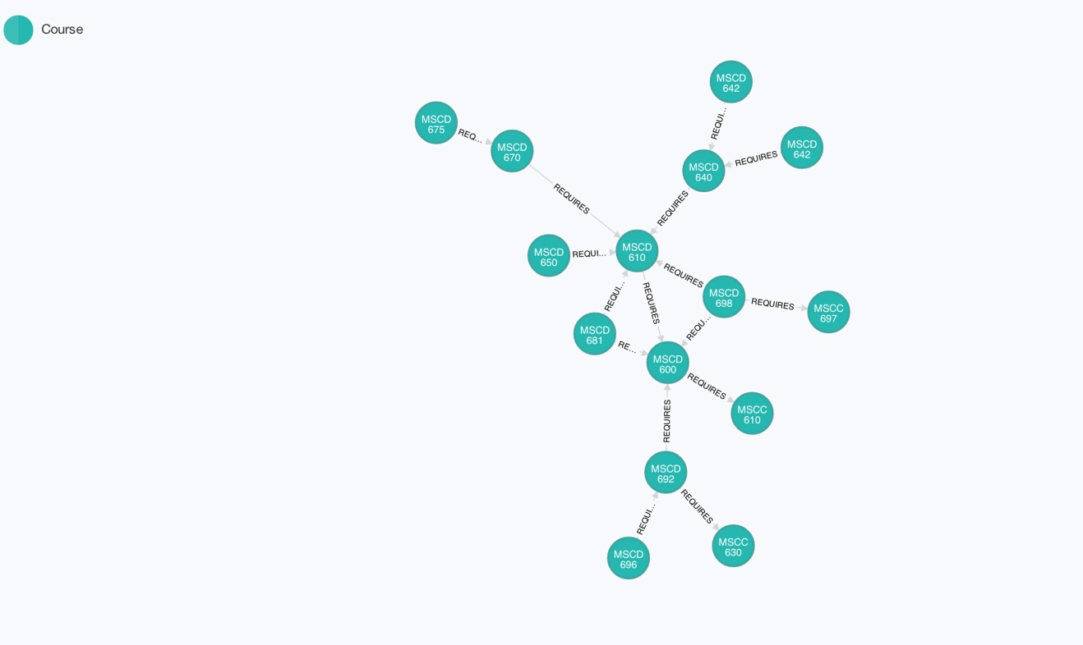16. The image above is a graph of the Regis University, College of Computer and Information Sciences, Database Technologies courses and their prerequisites. Each node has a Course ID, and Title property associated with it. Your task is to create and execute the Cypher statements required to implement this graph. You can find the needed data from the Regis University course catalog located here: (<http://www.regis.edu/~/media/Files/University/Academic/Course%20Catalog/2013-14%20Catalog/GradCourseDesc.ashx>, pages 424-426).

Insert a copy of your Cypher statements here:

CREATE (mscc610:Course { courseid: 'MSCC610', title: 'Information Technology Concepts' }),(mscc610)-[:REQUIRES]->(mscc610)

CREATE (mscc630:Course { courseid: 'MSCC630', title: 'Enterprise Architecture' }),(mscc630)-[:REQUIRES]->(mscc697)

CREATE (mscc697:Course { courseid: 'MSCC697', title: 'Information Technology Research Methods' }),(mscc697)-[:REQUIRES]->(mscc610)

CREATE (mscd600:Course { courseid: 'MSCD600', title: 'Database Architecture' }),(mscd600)-[:REQUIRES]->(mscc610)

CREATE (mscd610:Course { courseid: 'MSCD610', title: 'Database Concepts' }),(mscd610)-[:REQUIRES]->(mscd600)

CREATE (mscd640:Course { courseid: 'MSCD640', title: 'Oracle Database Administration' }),(mscd640)-[:REQUIRES]->(mscd610)

CREATE (mscd642:Course { courseid: 'MSCD642', title: 'Database Backup and Recovery' }),(mscd642)-[:REQUIRES]->(mscd640)

CREATE (mscd644:Course { courseid: 'MSCD644', title: 'Database Performance and Tuning' }),(mscd644)-[:REQUIRES]->(mscd640)

CREATE (mscd650:Course { courseid: 'MSCD650', title: 'PL/SQL Programming' }),(mscd650)-[:REQUIRES]->(mscd610)

CREATE (mscd670:Course { courseid: 'MSCD670', title: 'Middleware Architecture and Database Applications' }),(mscd670)-[:REQUIRES]->(mscd610)

CREATE (mscd675:Course { courseid: 'MSCD675', title: 'Database Technologies and Service Oriented Architecture' }),(mscd675)-[:REQUIRES]->(mscd670)

CREATE (mscd681:Course { courseid: 'MSCD681', title: 'Data Warehouse Design' }),(mscd681)-[:REQUIRES]->(mscd610), (mscd681)-[:REQUIRES]->(mscd600)

CREATE (mscd692:Course { courseid: 'MSCD692', title: 'Database Practicum I' }),(mscd692)-[:REQUIRES]->(mscc630), (mscd692)-[:REQUIRES]->(mscd640)

CREATE (mscd696:Course { courseid: 'MSCD696', title: 'Database Practicum II' }),(mscd696)-[:REQUIRES]->(mscd692)

CREATE (mscd698:Course { courseid: 'MSCD698', title: 'Database Technologies Thesis' }),(mscd698)-[:REQUIRES]->(mscd610), (mscd698)-[:REQUIRES]->(mscc697)

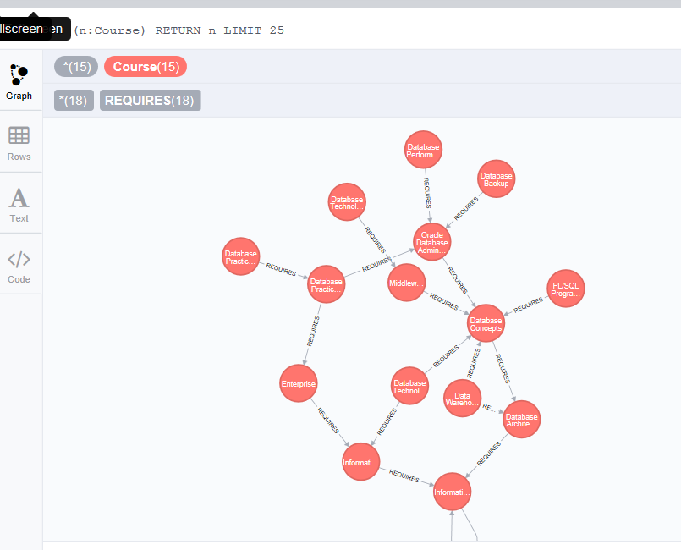

-----------------------------------------------------------------------------------

17. Now that you have created your own graph. Show the prerequisites for the MSCD 681 course. First show them as a graph, then just list the names of the courses.

Paste a screenshot of the graph below:

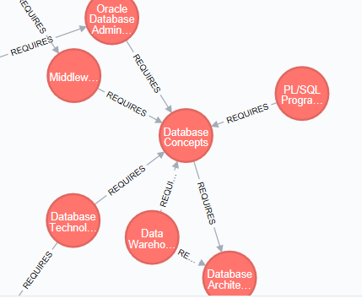

Paste a screenshot of the listing below:

**CREATE (mscd681:Course { courseid: 'mscd681', title: 'Data Warehouse Design' }),(mscd681)-[:REQUIRES]->(mscd610), (mscd681)-[:REQUIRES]->(mscd600)**

**MSCD681(Data Warehousing) requires MSCD610 (Database Concepts) and MSCD600(Database Architecture).**

-----------------------------------------------------------------------------------

18. Using your graph, return the three most common prerequisite courses along with the number of courses that requires each course.

Paste your Cypher query here:

Paste your results here:

**Database Concepts** is required as a prerequisite by Middleware Architecture and Database Applications, Oracle Database Administration, Database Architecture

**Information Technology Concepts**

**Oracle Database Administration**

-----------------------------------------------------------------------------------

19. Display a graph of the number of nodes in your database. (Hint, use the webadmin interface).

Paste Screenshot below:

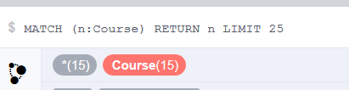

-----------------------------------------------------------------------------------

20. Export your graph as a JSON file.

Paste results below:

{"columns":["n"],"data":[{"row":[{"title":"Information Technology Concepts","courseid":"mscc610"}],"meta":[{"id":257,"type":"node","deleted":false}],"graph":{"nodes":[{"id":"257","labels":["Course"],"properties":{"title":"Information Technology Concepts","courseid":"mscc610"}}],"relationships":[]}},{"row":[{"title":"Information Technology Research Methods","courseid":"mscc697"}],"meta":[{"id":258,"type":"node","deleted":false}],"graph":{"nodes":[{"id":"258","labels":["Course"],"properties":{"title":"Information Technology Research Methods","courseid":"mscc697"}}],"relationships":[]}},{"row":[{"title":"Enterprise Architecture","courseid":"mscc630"}],"meta":[{"id":259,"type":"node","deleted":false}],"graph":{"nodes":[{"id":"259","labels":["Course"],"properties":{"title":"Enterprise Architecture","courseid":"mscc630"}}],"relationships":[]}},{"row":[{"title":"Database Architecture","courseid":"mscd600"}],"meta":[{"id":260,"type":"node","deleted":false}],"graph":{"nodes":[{"id":"260","labels":["Course"],"properties":{"title":"Database Architecture","courseid":"mscd600"}}],"relationships":[]}},{"row":[{"title":"Database Concepts","courseid":"mscd610"}],"meta":[{"id":261,"type":"node","deleted":false}],"graph":{"nodes":[{"id":"261","labels":["Course"],"properties":{"title":"Database Concepts","courseid":"mscd610"}}],"relationships":[]}},{"row":[{"title":"Oracle Database Administration","courseid":"mscd640"}],"meta":[{"id":262,"type":"node","deleted":false}],"graph":{"nodes":[{"id":"262","labels":["Course"],"properties":{"title":"Oracle Database Administration","courseid":"mscd640"}}],"relationships":[]}},{"row":[{"title":"Database Backup and Recovery","courseid":"mscd642"}],"meta":[{"id":263,"type":"node","deleted":false}],"graph":{"nodes":[{"id":"263","labels":["Course"],"properties":{"title":"Database Backup and Recovery","courseid":"mscd642"}}],"relationships":[]}},{"row":[{"title":"Database Performance and Tuning","courseid":"mscd644"}],"meta":[{"id":264,"type":"node","deleted":false}],"graph":{"nodes":[{"id":"264","labels":["Course"],"properties":{"title":"Database Performance and Tuning","courseid":"mscd644"}}],"relationships":[]}},{"row":[{"title":"PL/SQL Programming","courseid":"mscd650"}],"meta":[{"id":265,"type":"node","deleted":false}],"graph":{"nodes":[{"id":"265","labels":["Course"],"properties":{"title":"PL/SQL Programming","courseid":"mscd650"}}],"relationships":[]}},{"row":[{"title":"Middleware Architecture and Database Applications","courseid":"mscd670"}],"meta":[{"id":266,"type":"node","deleted":false}],"graph":{"nodes":[{"id":"266","labels":["Course"],"properties":{"title":"Middleware Architecture and Database Applications","courseid":"mscd670"}}],"relationships":[]}},{"row":[{"title":"Database Technologies and Service Oriented Architecture","courseid":"mscd675"}],"meta":[{"id":267,"type":"node","deleted":false}],"graph":{"nodes":[{"id":"267","labels":["Course"],"properties":{"title":"Database Technologies and Service Oriented Architecture","courseid":"mscd675"}}],"relationships":[]}},{"row":[{"title":"Data Warehouse Design","courseid":"mscd681"}],"meta":[{"id":268,"type":"node","deleted":false}],"graph":{"nodes":[{"id":"268","labels":["Course"],"properties":{"title":"Data Warehouse Design","courseid":"mscd681"}}],"relationships":[]}},{"row":[{"title":"Database Practicum I","courseid":"mscd692"}],"meta":[{"id":269,"type":"node","deleted":false}],"graph":{"nodes":[{"id":"269","labels":["Course"],"properties":{"title":"Database Practicum I","courseid":"mscd692"}}],"relationships":[]}},{"row":[{"title":"Database Practicum II","courseid":"mscd696"}],"meta":[{"id":270,"type":"node","deleted":false}],"graph":{"nodes":[{"id":"270","labels":["Course"],"properties":{"title":"Database Practicum II","courseid":"mscd696"}}],"relationships":[]}},{"row":[{"title":"Database Technologies Thesis","courseid":"mscd698"}],"meta":[{"id":271,"type":"node","deleted":false}],"graph":{"nodes":[{"id":"271","labels":["Course"],"properties":{"title":"Database Technologies Thesis","courseid":"mscd698"}}],"relationships":[]}}],"stats":{"contains_updates":false,"nodes_created":0,"nodes_deleted":0,"properties_set":0,"relationships_created":0,"relationship_deleted":0,"labels_added":0,"labels_removed":0,"indexes_added":0,"indexes_removed":0,"constraints_added":0,"constraints_removed":0}}

-----------------------------------------------------------------------------------